EES 330 Lab 6
Chemical Inputs and Outputs at Subduction Zones
Modified from a MARGINS exercise by Dr. Karin Block, LDEO

Material transfer during tectonic processes strongly controls which rocks and minerals form during volcanism. The distribution of materials, as well as their chemical compositions, reveals much about the processes involved in forming them. Identifying magma sources contributing to subduction-related volcanism is one of the keys to assessing the hazards associated with eruptive events. In this exercise, we explore the composition of the various units or reservoirs involved during subduction at two volcanic arcs. We will be extracting data from global collections and visualizing the distribution of major chemical species in the system to construct hypotheses regarding the nature of arc volcanism. For the first part of the assignment, you will retrieve and plot data to draw conclusions about observed elemental abundances in volcanic rocks from two volcanic arcs along the eastern Pacific margin. You will write a short report detailing your observations and conclusions as guided by the questions in this handout.

Some tips:
- Your basic knowledge of rocks and minerals will come in handy. Use it!
- The datasets are generated by you, from real published data, so they will be messy. Do your best to wade through and look for the norm, not the exception!
- If you get stuck with a technical question, ask for help.

Instructions:

- Log on to EarthChem (http://www.earthchem.org) and click the ‘Search EarthChem’ tab on the top left.
- Create a Search Query by clicking the ‘set’ button next to ‘Location’. Click on the icon for ‘Define a polygon on an interactive map’ to create a polygon query that looks like this:
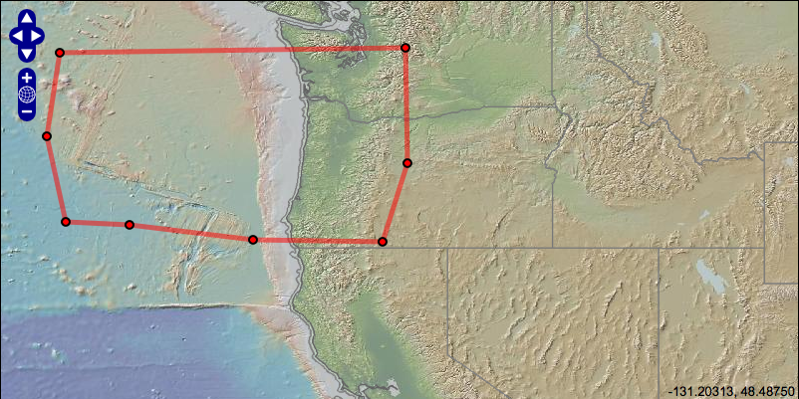
- The database will output a list of samples from PetDB, NAVDAT, GEOROC and USGS that satisfy the query criteria. Deselect GEOROC, as it replicates a lot of the data from NAVDAT.
- Click on the “Continue to Data Selection” button to retrieve your data.
- Under Data Access select “Get Chemical Data”. This will take you to the Advanced Output page. Under the column labeled Major Oxides deselect all. Also choose ⁸⁷Sr/⁸⁶Sr and ¹⁴³Nd/¹⁴⁴Nd from the Isotope Ratio column. Make sure you deselect all other chemical items.
- Choose from the radio buttons the following:
- Show samples with any of the below values defined.
- Display as text file
- Output one row per sample
- Download your data by clicking the Go To Data button on the upper right.
- Save File and then Open With Excel to make sure the document contains data. Once you have confirmed this, save your file as Cascadia_YourName.txt. (Be sure to save it as .txt and not as .xls!

- Download GeoMapApp (for Windows!) onto the desktop from http://www.geomapapp.org/
- Double-click icon to open GeoMapApp and select the Mercator Map.
- To import your data, go to:
File Import Table or Spreadsheet from tab delimited ASCII text formatted file Select your Cascadia dataset.
- In the Configure window, change the symbol size to 50%. GeoMapApp will warn you that you have more than 10000 points. Ignore this warning and click ok.
- Zoom in to view your data.
- Click ‘Color by Value’ and select SiO₂. This will bring up a histogram of colors:

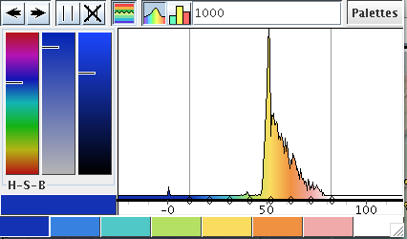

- The default coloring scale shows most of your data as yellowish. To express the compositional variation with greater color variation, move the gray vertical lines bounding the graph until you obtain a wider range of colors that reflects the range of values in your data. The result could look something like this, depending on the color palette you select (this is the default):

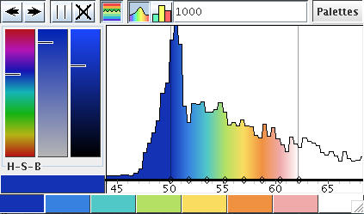

Questions:
- What predominant rock type (mafic, intermediate or felsic) might you expect to find at a mid-ocean ridge? What about about on a continental arc? Justify your answers. Composition reminder: Mafic = 45-55 wt. % SiO₂, Intermediate = 55-63 wt. % SiO₂, and Felsic = > 63 wt. % SiO₂.

Select Graph in GeoMapApp and create a scatter plot of SiO₂ vs. Longitude. I recommend dragging the blue line to make your plot zoom in on the data points. Save this as a JPEG file (Cascadia_SiO2_Long.jpg) and include it, along with all your other plots, with your Lab Report.

- Describe the scatter plot. Is there a pattern between the location (longitude of the samples) and the oxide content? Does this plot change or reinforce your response to Question A?

Fill in the mineral formulas for some of the common rock-forming minerals listed below to answer the next set of questions.

Ca-Plagioclase (anorthite) –  Na-Plagioclase (albite) –  K-Feldspar -- | Olivine –  Pyroxene –

- Examine your SiO₂ vs. Longitude plot. Color the symbols (“Color by Value”) by MgO value. Adjust the histogram to display a range of colors corresponding to the full range of values.

- At which location is MgO most abundant? SiO₂?

- In GeoMapApp, color the symbols again by SiO₂ value. Then create four additional graphs:

FeO vs. MgO
K₂O vs. MgO
Na₂O vs. MgO
Na₂O vs. CaO.

Again, adjust the blue lines to zoom in on the bulk of the data.

- For each graph, describe what correlation you see between the elements. For example, when oxide A is high, is oxide B low and vice versa? How does SiO₂ fit into this correlation?
- Based on the correlation you described in question E, which minerals are most likely to be present in the rocks you have described? Your answer should be specific, i.e., when A is high, and B is low, I expect to find minerals X and Y in the rock.

- Based on your understanding of Bowen’s Reaction Series, the composition of the various inputs and outputs of the volcanic system and the distribution of rocks at mid-ocean ridge and continental arc settings, create a hypothesis on how oxides move through the volcanic system or where these chemical species prefer to reside in the volcanic system.
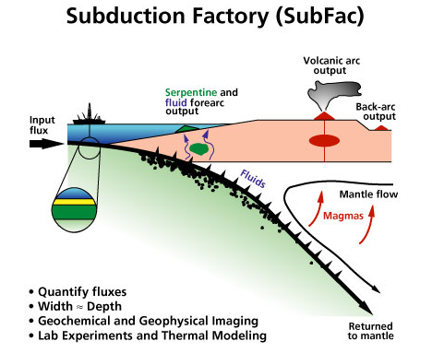

Geoscientists use chemical tracers to elucidate the sources of materials that contribute to the production of magmas. Among the common tools employed in this task are trace elements and isotopes. Below we will take a look at an example of how isotopes can give us powerful information on various inputs at subduction zones.

A Simple Background on Isotope Tracers:

Rubidium (Rb) is an element that is found in higher concentrations in continental rocks than on rocks from the ocean floor. It is incompatible element in many crystal structures of minerals. During mantle melting, it is freed from mantle minerals and mobilized into the magma. During crystallization of magmas, it tends to be concentrated in the residual liquid left over after common minerals have crystallized. The concentration of Rb is higher in continental rocks than in MORB. Rocks in the continental crust generally have Rb concentration greater than 20 ppm, while the mantle has Rb concentration of less than 0.1 ppm. Among the rubidium isotopes, ⁸⁷Rb is radioactive and decays to ⁸⁷Sr. Sr is a sometimes compatible element in that it can substitute for calcium in many common mineral structures. Since continental crust rocks start out with higher amounts of Rb, the ratio of ⁸⁷Sr to ⁸⁶Sr tends to be higher on continents. Geochemists use this relationship between Rb and Sr as a geochemical tracer.

Another geochemical tracer is the ratio of two neodymium isotopes, ¹⁴³Nd and ¹⁴⁴Nd.
Samarium is a lanthanide or rare earth element (REE) with a radioactive isotope, ¹⁴⁷Sm that decays to ¹⁴³Nd, another REE. Each episode of melting in the mantle mobilizes Nd into the melt more readily than Sm. A high amount of radiogenic ¹⁴³Nd relative to the stable neodymium isotope ¹⁴⁴Nd indicates fewer episodes of melting and mobilization and therefore a composition closer to chondritic or primordial earth.

Exercise:
I. Color the symbols according to ⁸⁷Sr/⁸⁶Sr composition. Make a graph of longitude vs. strontium isotope ratio. What are your observations? Repeat for ¹⁴³Nd/¹⁴⁴Nd. Based on what you just learned about the Rb-Sr and Sm-Nd isotope systems and your observations, formulate a hypothesis on what you think are the rock inputs and outputs at the Central American arc.

References and Resources:

EarthChem: http://www.earthchem.org

GeoMapApp: http://www.marine-geo.org/geomapapp/

