Name__________________________ class____
Ocean Basins Worksheet
Part 1: Follow in class and label the parts of the profile
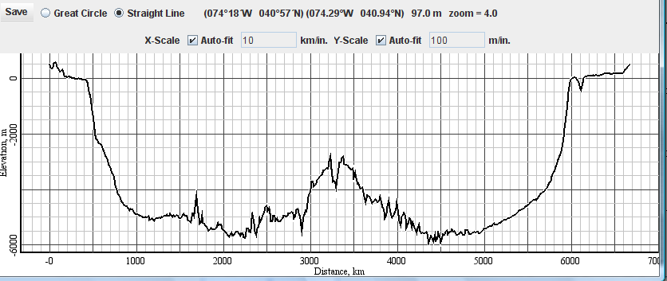
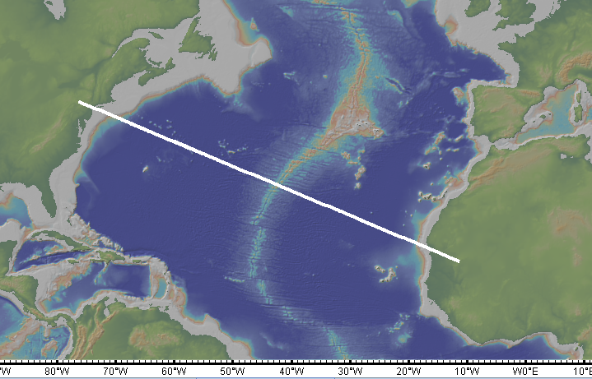

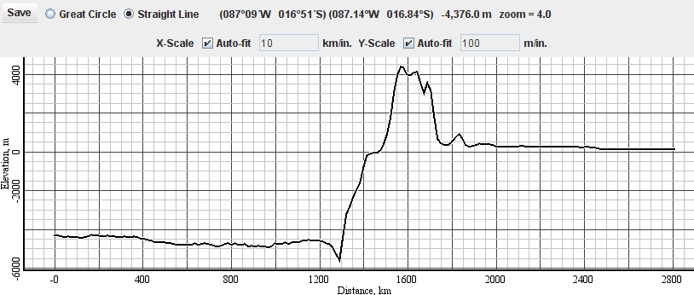
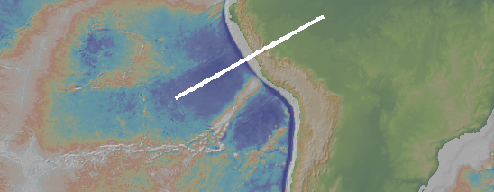

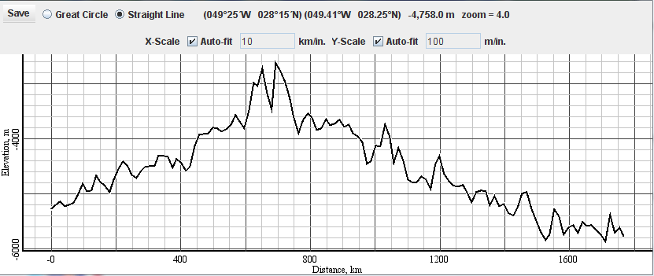
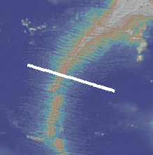
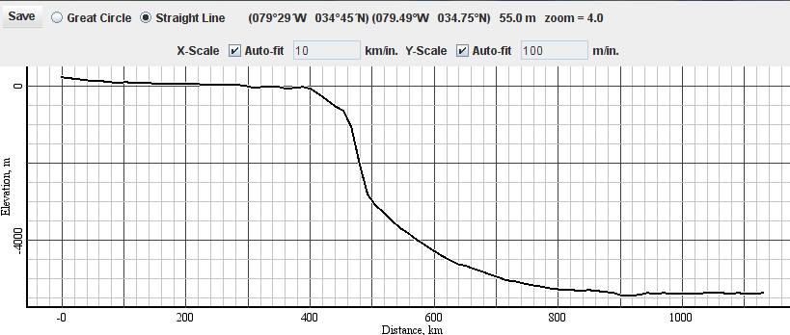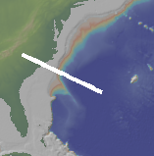

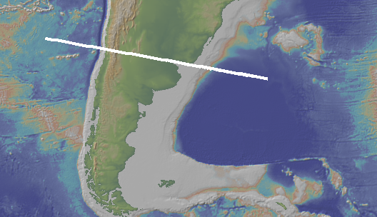
Part 2: The 3 maps below refer to the profiles on the following pages. First you must determine which map matches which profile. Label both the map and the profiles with the following labels. First start by drawing a line at sea level.
South America- label the Pacific Ocean, Atlantic Ocean, Andes mountains, continental shelf, continental slope, abyssal plain

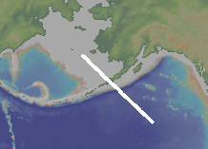
Alaska- label continental shelf, island (volcanic), ocean trench, Pacific Ocean, abyssal plain
This profile includes the Bering Sea. Do you think that the profiled section of the Bering Sea is made of Continental Crust or Oceanic Crust?________________________

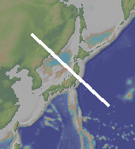
Asia and Japan- label Asia, Japan, ocean trench, Sea of Japan, Pacific Ocean. Which sea/ocean is deeper?_______________

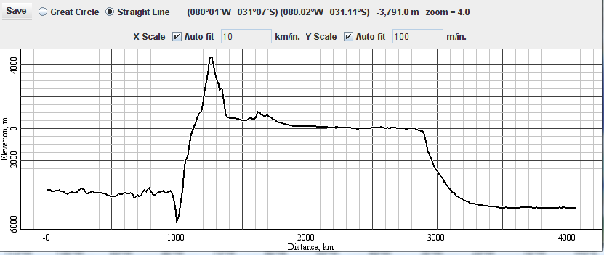
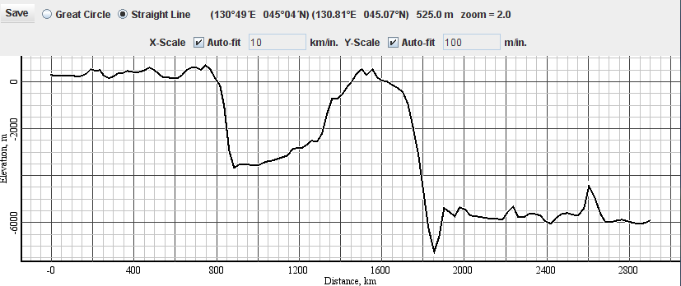
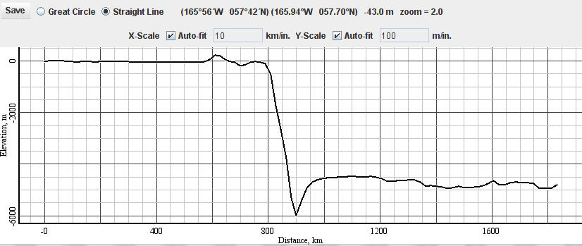

Part 3: Look at the following map and profile, draw a line at sea level, and label the profile with appropriate labels.
